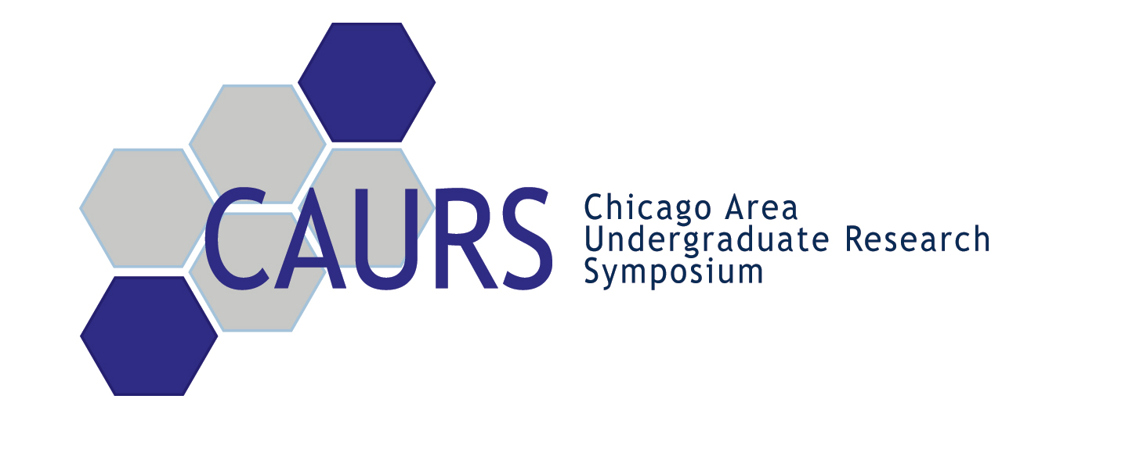
ORAL PRESENTATIONS

Marco Mendez-Duarte
Katelin Mirkin
Alexander Purcell
Ryosuke Kita

ORAL PRESENTATIONS

Jeff Kaplan
Michael DiMarco
Genna Cohen
Amy Winans

ORAL PRESENTATIONS

Yonatan Kahn
Heather Selby
Jane Solomon
Christina David

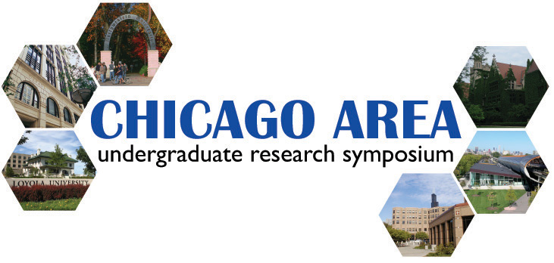

Welcome to the 3rd Annual CAURS!

Welcome to the 3rd Annual CAURS!

Welcome to the 3rd Annual CAURS!

Participants
A – F
Participants
G – P
Participants
Q – Z
Guests, Judges, Advisors

